B. In-Depth Explanation & Analysis
1. Conventional vs. Non-Conventional Energy
- Conventional: Sources we've used for a long time (Coal, Petroleum, Firewood). They are non-renewable (will run out) and cause pollution.
- Non-Conventional: Newer sources (Solar, Wind, Tidal, Geothermal, Biogas). They are renewable (infinite), eco-friendly, but initially expensive to set up.
2. Target Area Planning India has huge regional disparities. A blanket plan won't work for Punjab (rich) and Odisha's tribal belt (poor).
- Target Area Planning: Identifies specific backward regions (like drought-prone districts) and makes special plans just for them.
- Target Group Planning: Identifies specific poor communities (like small farmers, tribal people) and focuses on their upliftment.
3. Sustainable Development: The Indira Gandhi Canal Lesson This massive canal brought Himalayan water to the Rajasthan desert.
- Success: Crops now grow in the desert, bringing prosperity.
- Failure: Over-irrigation led to waterlogging and soil salinity, threatening long-term farming.
- Lesson: True development must be sustainable—we must use water efficiently (drip irrigation) to avoid ruining the land for future generations.
Mentor’s insight:
- Minerals are divided in two categories metallic minerals further divided into ferrous and non-ferrous mineral and non-metallic minerals further divided into fuel and other non-metallic mineral.
- Minerals in India are distributed in three main belts: The North-eastern Plateau region, The South-Western Plateau Region and The North-Western Region.
- Most important part of this chapter is mines and distribution of minerals, for both questions and map work. Along with oil refineries and conventional energy resources.
- HVJ pipeline very important for MCQs.
- Types of Non-conventional energy resources and conservation of mineral resources are often asked in short answer type questions.

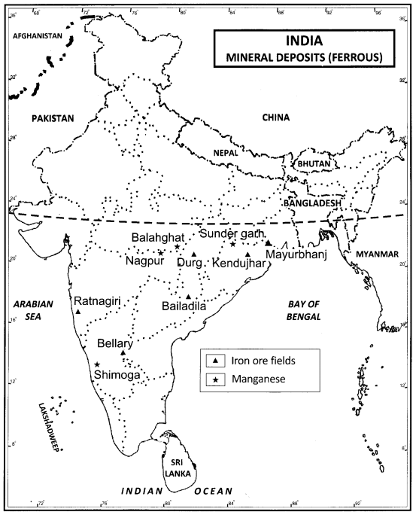
- NITI Ayog was formed on 1 January 2015 replacing the planning commission.
- Hill Area Development Programme under the fifth five year plan covering 15 districts, Drought Prone Area Programme under fourth five year plan providing employment, later focusing on irrigation, land development programme, afforestation and other such developmental works.
- Make sure to revise the ITDP in Bharamaur region case study.
- Important publications such as “The Population bomb” by Ehrlich in 1968 and “The Limits to Growth” by Meadows and others in 1972.
- Measures to promote sustainable development are must to revise once.
- Case study over Indira Gandhi Canal is very important.

